**“We All Belong” Presentation**

**St. Sebastian and St. Catherine Facing Racism**

Speaker: Sister Barbara Pfarr SSND  
bpfarr@wisdomwisconsin.org

**Thursday 3/21/24**

**St. Sebastian Church Hall**

**Program at 6:00pm**

***What is “Christian” Nationalism and why is it dangerous?***

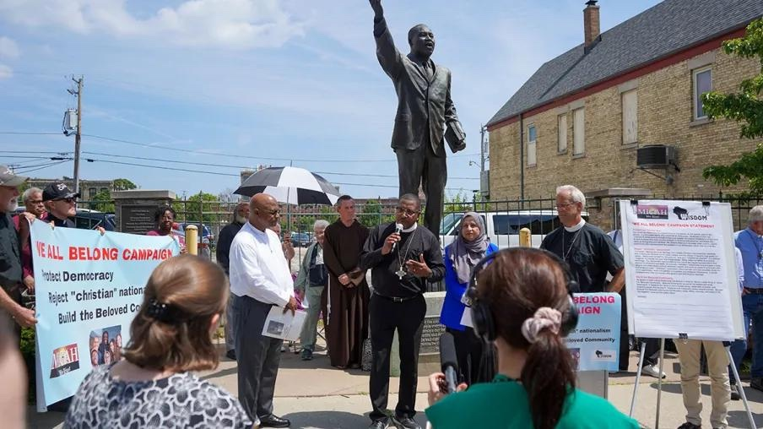

* **PROTECT DEMOCRACY**
* **REJECT “CHRISTIAN” NATIONALISM**
* **BUILD THE BELOVED COMMUNITY**

Brought to you by

WISDOM/MICAH

