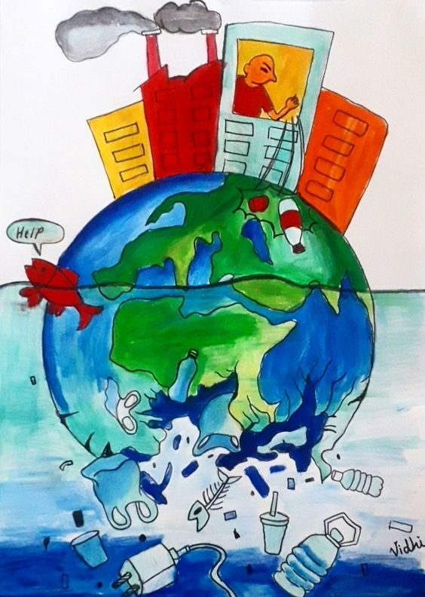  - Thursday, April 20, 1 PM  State Environment Issues Presented by: Wisconsin Conservation Voters  Join Greener Oconomowoc for an afternoon with Wisconsin Conservation Voters (WCV) as they report on state-wide issues. Find out about Clean Energy, Eliminating PFAS From Water, Automatic Voter Registration, Work Force Development for Clean Energy, and Greater Accessibility to City Grants for Clean Energy Development. Participate in WCV’s Conservation Lobby Day April 25th in Madison!   | Event Held at Oconomowoc Public Library  Funding for PFAF Remediation and Filtration  ____  Training and Apprenticeships for Clean Energy Jobs  ____  Assistance to Communities in Applying for Grants  ____  Participate in Conservation Lobby Day April 25th!

