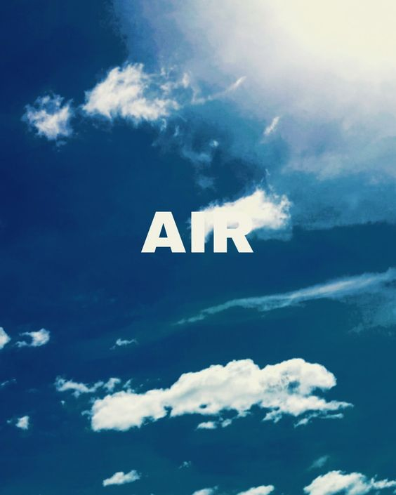  - Thursday March 16, 7Pm  Wisconsin’s Air Quality!  Greener Oconomowoc welcomes Wisconsin DNR’s Craig Czarnecki and Lindsay Hass, Air Quality Managers, to talk about the air quality in our state. Find out about Wisconsin’s Air Management Program, trends in air quality over the last 20+ years and current state and local issues. Join us for this most informative evening!   | Event Held At Waukesha State Bank Ocononomowoc  ____  Learn About Our State Air Management Program  ____  What Are theTrends in Our State’s Air Quality  ____  What are Current State and Local Issues?  You Have Room for One More Here!

