  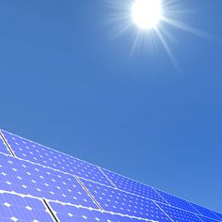
    - 7pm November 21st ^{a BIG solar project}
  Soon four towns in Jefferson County will get their electricity from solar panels planted in farmers’ fields. While parts of the rural landscape will change, this renewable source of power will reduce the use of fossil fuels and carbon emissions. Tammi Vetrano, Local Representative from Sinnissippi Solar Project, and Cooper Johnson, Project Manager from Invenergy LLC, will talk about this brand new solar project.
  eVENT hELD aT: wHELAN’S cOFFEE AND iCE cREAM 163 e. wISCONSIN OCONOMOWOC
  LEARN ABOUT A LOCAL SOLAR PROJECT
  FIND OUT ABOUT THE ADVANTAGES OF SOLAR ENERGY
  ASK QUESTIONS ABOUT THIS SOLAR PROJECT’S PROGRESS
  CONSIDER FUTURE SOLAR DESIGNS
  SPONSORED BY
  GREENER OCONOMOWOC’S
  COFFEE
  CONVERSATIONS

