  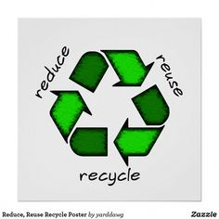
    - 7 PM THURSDAY October 24th
  recycling
  revisited
  sharpen your recycling skills and awareness!
  We all recycle, but are we aware of what is truly recyclable? What happens once our recyclables are taken away? What industries benefit from our used wares? Now that Asian markets have greatly decreased their acceptance of our recyclables, what happens to them? Nate Austin from Johns Disposal Services and Analiese Smith, Waukesha County’s Solid Waste Supervisor, will be on hand to answer these and many other questions!
  Event held at Oconomowoc Memorial hospital – silver Lake Room
  play our game and sharpen your recycling skills
  new products from recycled goods
  waste product management
  consumer awareness
  Sponsored by
  Greener Oconomowoc’s Coffee Conversations

