*A Writing and Mindfulness Workshop—created for a peace-filled holiday season*

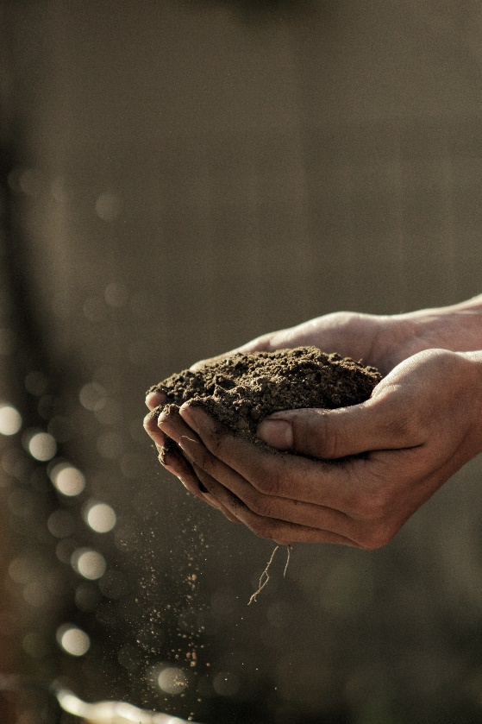

Cultivating Balance

Wednesday, Nov. 21 - 6:30-8:00pm

Cultivating Intention

Wednesday, Dec. 5 - 6:30-8:00pm



FEE: $25/class (or $45 if sign up for both at the same time)

Minimum number required to hold class

Deadline 3 days prior to date of each class.

PREREGISTRATION REQUIRED:

Call: 262-361-3316

Email: WakeUpTheWriterWithin@gmail.com

Additional Info: WakeUpTheWriterWithin.com

Facilitator: Joanne Nelson,

*Joanne is a certified meditation and mindfulness instructor, is a writer and retreat/workshop leader. Her writing and wellness offerings allow students to engage, restore, and re-story.*

Center for Well-Being Lake Country, LLC

Providing Opportunities for Spiritual Growth & Wellness

301 Cottonwood Ave., Hartland, WI 53029 • (262) 367-0607 • [www.c4wb.com](http://www.c4wb.com) • [sandra@c4wb.com](mailto:sandra@c4wb.com)

Cultivating Balance...

Experience the holidays from a place of balance and perspective. Discover your center and learn how to stay grounded and connected to what really matters. Let this innovative workshop provide you with easy tools for staying present, open, and peaceful during these busy days. Guided writing, mindfulness exercises, discussion, and reflection will all be part of this relaxing evening of self care.

Cultivating Intention...

What do you desire in your life? Everything we do begins with an intention. What intentions do you have for this holiday season? What are your intentions as you look towards a new year?

Our intentions are like seeds—if we ignore them, not much happens, but if we plant and nourish those seeds they can grow and flourish.

What do you want to plant in your life right now? What are you dreaming about, or holding in your heart?

Join me for writing activities and mindfulness exercises designed to help you nurture the seeds of your deepest intentions.