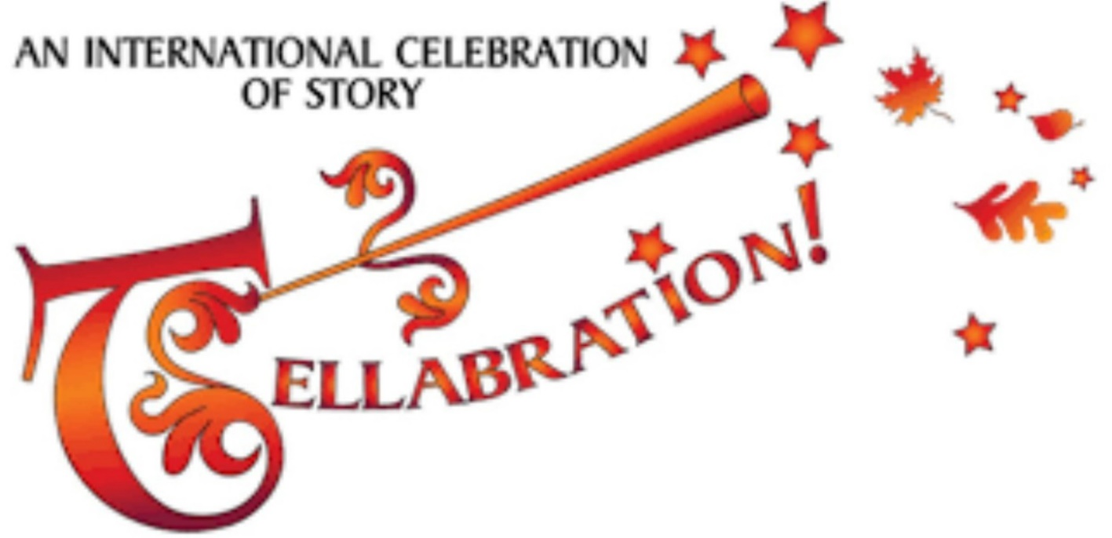

**TM**

***The 28th annual Milwaukee*   
TELLABRATION 2018   
A Night of Storytelling for Adults**

**Saturday, November 17, 2018 at 7pm  
*Mount Mary University’s Steimke Hall,   
2900 N Menomonee River Pkwy, Milwaukee WI***

***Cost: $5 at the door***

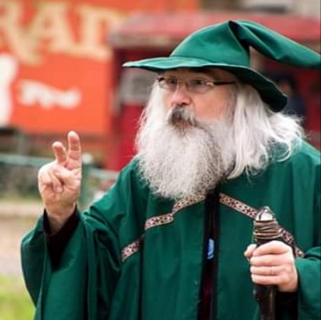 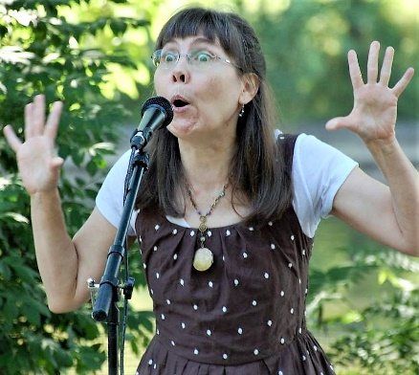 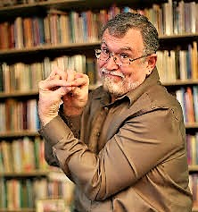 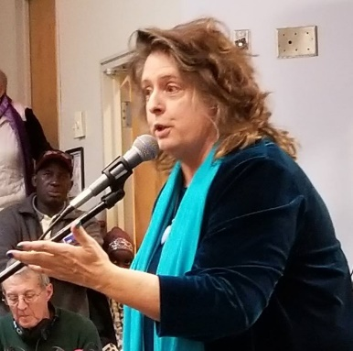

Special Guest Storyteller Dan Keding from Urbana, IL and area storytellers   
Paul Akert, Aaron Hardt, Erin Johnston, Elizabeth Matson   
with Emcee Tom Clark and Proclamation Reader, Miss Chris. The Milwaukee Area Story Telling Guild (M.A.S.T.) has been hosting this event since 1990!

TELLABRATION is a worldwide storytelling event coordinated by the National Storytelling Network and produced locally. It celebrates the art of storytelling  
and links storytelling enthusiasts on the same weekend around the globe.

**Information at:** [**http://www.organicarts.info/**](http://www.organicarts.info/)   
*Facebook Event Page:* [*https://www.facebook.com/events/243110336386474/*](https://www.facebook.com/events/243110336386474/)