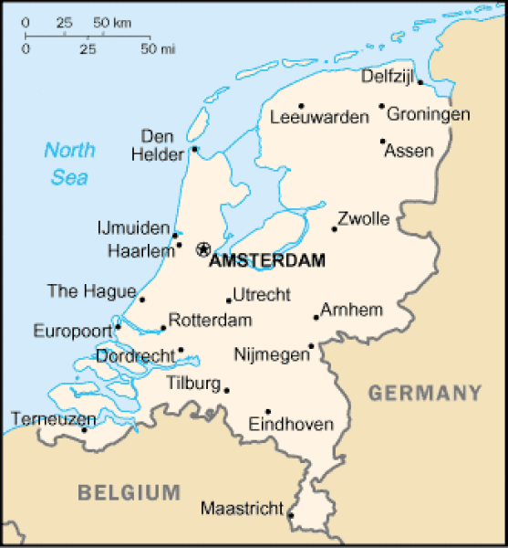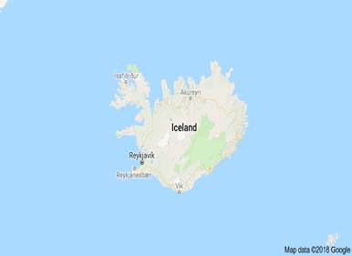  Nov. 8th 7PM  Ecotourism  Oconomowoc High School Students Share Summer European Ecotourism Experiences  Oconomowoc High School students and their teachers will share what they learned from their European Ecotourism experience this summer. Come and learn what our European neighbors are doing to address their concerns about energy, climate change, and limited natural resources | Join us at Whelan’s Coffee and Ice Cream  ────  Learn About  Europe’s:  Renewable Energy and Sustainability  Innovative Technology  German Village Powered by Renewable Sources  ────  Coupons for Treats Given to Attendees!  Sponsored by Greener Oconomowoc’s  Coffee Conversations

