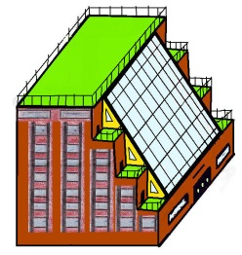CREATE YOUR OWN DIVERSE, MULTIGENERATIONAL COMMUNITY…

Interested in Riverwest Commons Cohousing?

[New construction on ½ acre southside of Center Street between Booth & Pierce]

**Cohousing is a resident owner-planned community of private residences focused on social interaction, diversity, caring, sustainability, and shared common spaces designed to foster resident interaction, including periodic common meals.**

**As currently planned, the ½-acre new construction community project may include:**

* **4+ story carbon neutral building**
* **24 or so individually owned fully equipped residences**
* **Roof top farm / event space (possible dog run?)**
* **Street level commercial space for possible restaurant, etc. for a walkable Center Street**
* **Common kitchen and dining facilities (in addition to kitchens in individual homes) & possible commercial kitchen rental for small batch businesses**
* **Meeting/meditation/library/exercise/tool/workshop/gallery areas/studios**
* **Children’s play areas/teen room**
* **Common electric car available for rental sharing**
* **Common balconies & patios**

Wanted: Families, Millennials, Boomers, Singles, Couples,

Roommates….let’s make a diverse Riverwest community!

GET IN ON THE GROUND FLOOR:

**Sunday, September 17th, 2017 6:30 p.m. – 8 p.m.**

**LOCATION MOVED TO:**

**Company Brewing (1 block from the site)**

**735 E Center St, Milwaukee, WI** · (414) 930-0909

*Program co-sponsored by First Unitarian Society of Milwaukee, Earth Justice Ministry*

*Contact instigator Nola J. Hitchcock Cross at* [njhcross@crosslawfirm.com](mailto:njhcross@crosslawfirm.com) or 414-224-0000 to arrange to host a meeting or just ask a question. [Other projects planned on 130 acres in Waldo, WI and on 14.5 acres abutting nature conservancy in Oak Creek or other available sites!]