***CARRIE ELKIN***

***and***

***DANNY SCHMIDT***

***IN CONCERT***

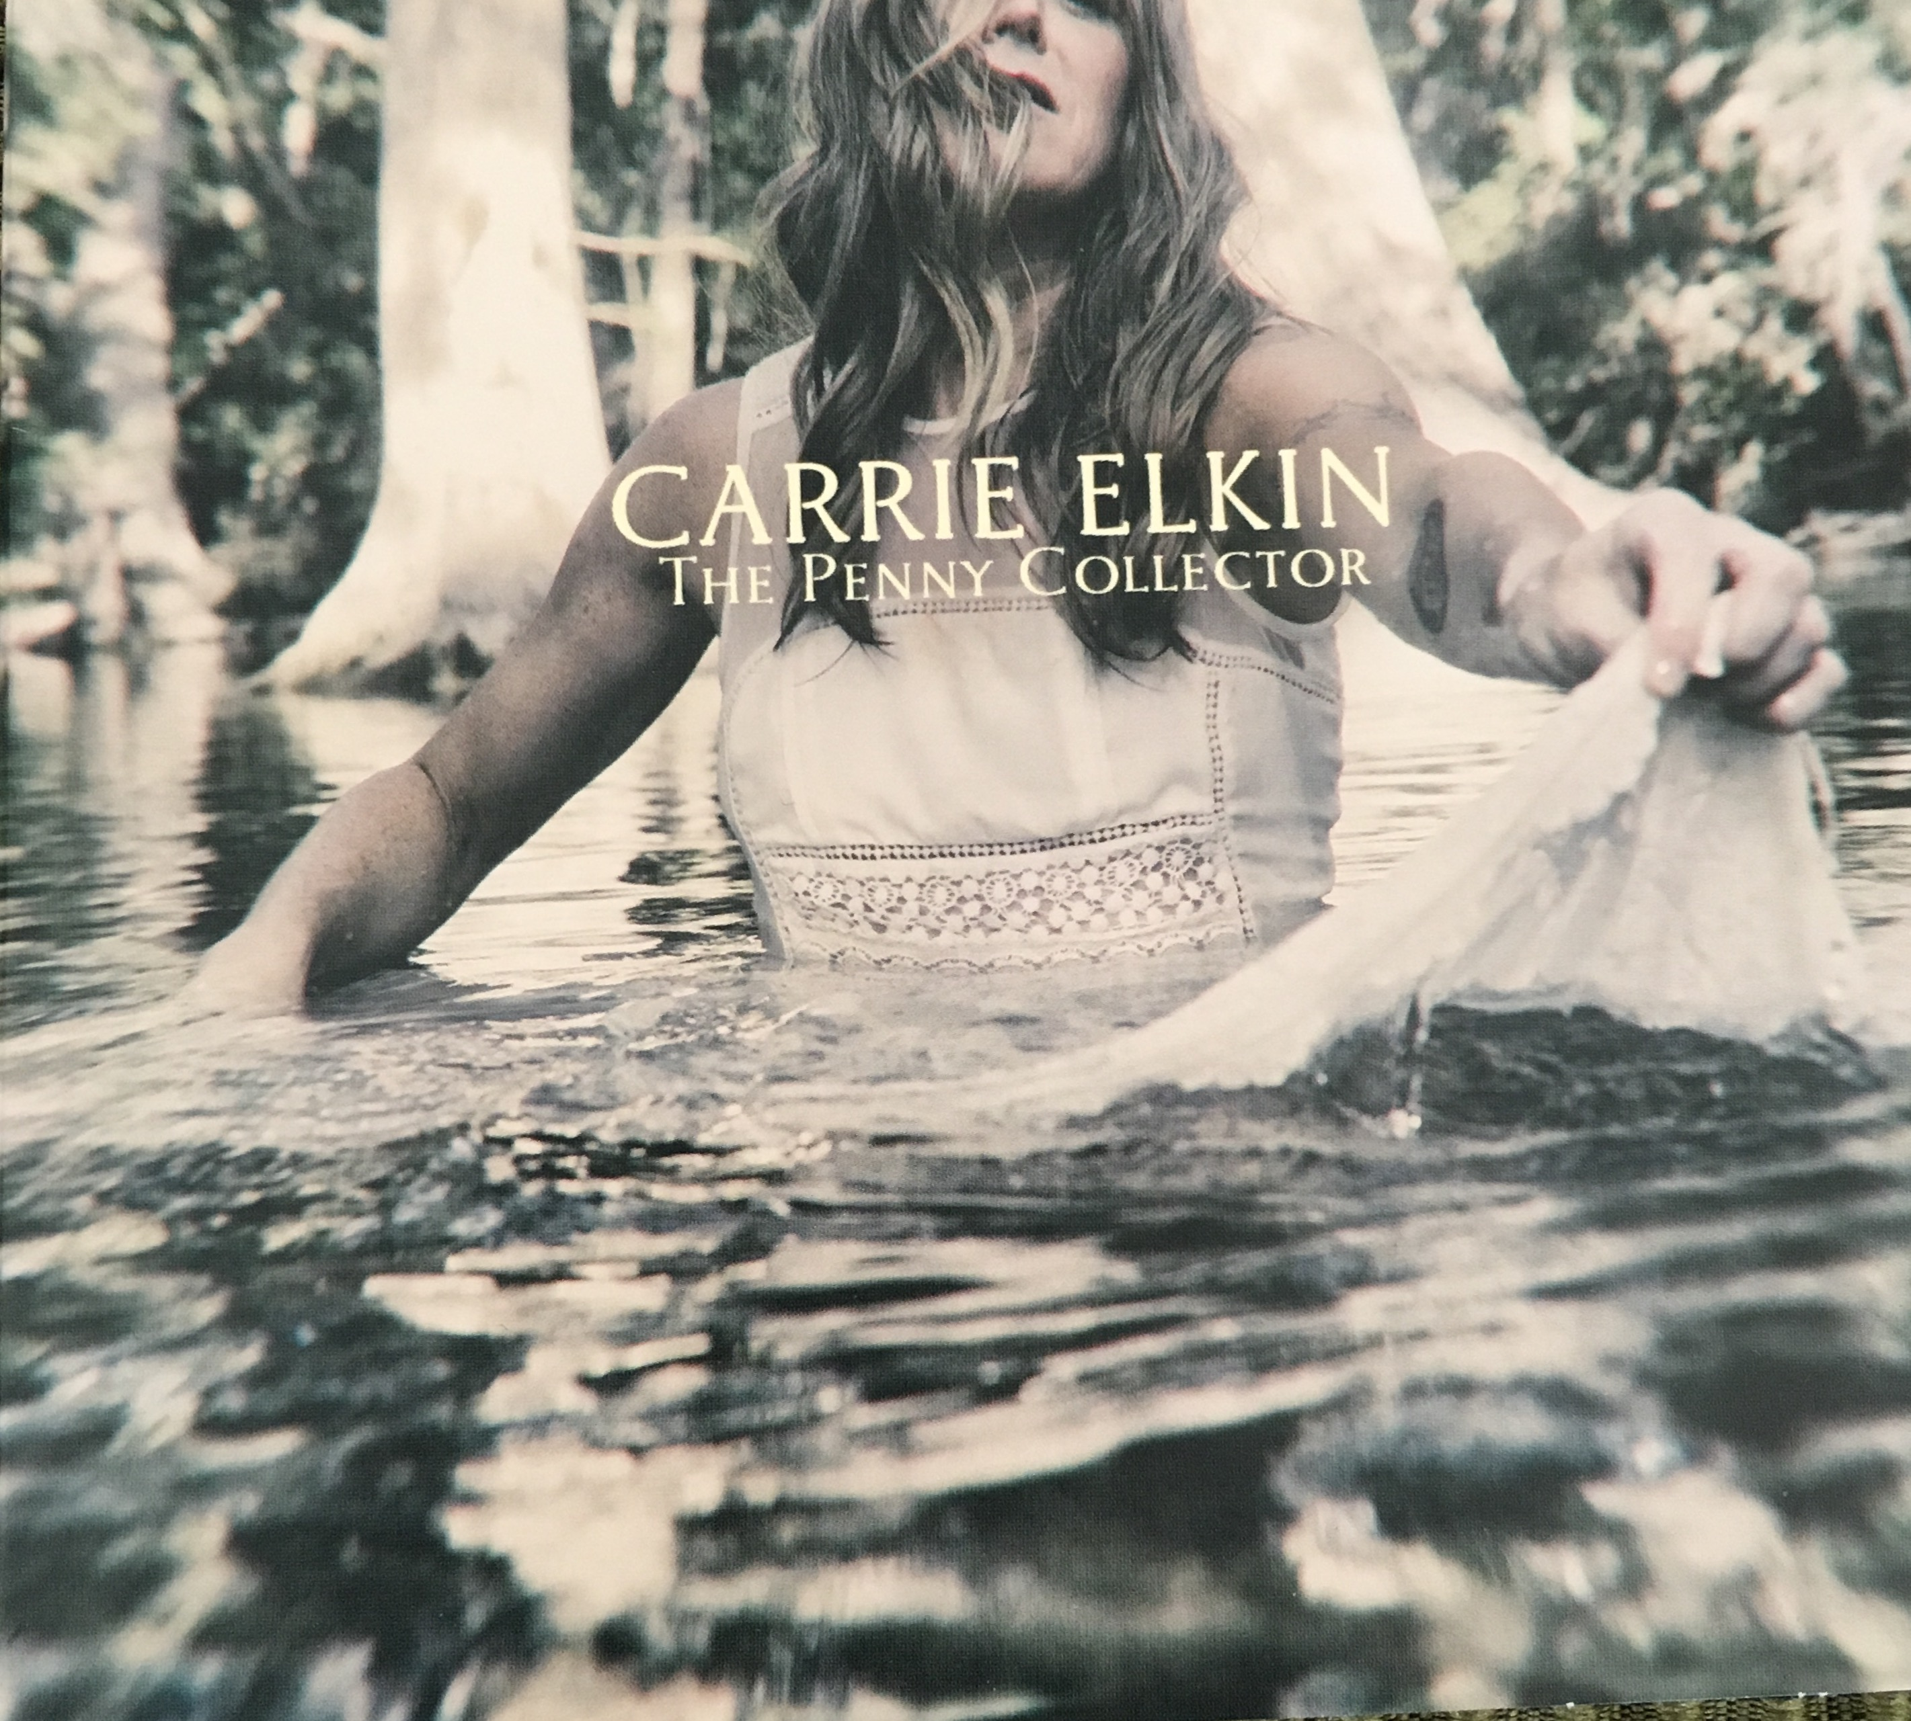

***CD RELEASE SHOW FOR “THE PENNY COLLECTOR” WWW.CARRIEELKIN.COM***

**"***Carrie Elkin is one of those rare artists with a tidal wave singing voice, and a stage whisper writing voice that brings you to the edge of your seat emotionally”*

*....Texas Music Magazine*

**TUESDAY - APRIL 25, 2017**

**Lake Country Unitarian Universalist Church**

**7:00PM - Doors open at 6:30 W299N5595 Grace Dr**

**Hartland, WI 53029**

**Tickets $20.00 Students $10.00**

**Contact for tickets: Donna Grzelak**

**Email:** [**lakecountryconcerts@yahoo.com**](mailto:lakecountryconcerts@yahoo.com)

**Phone: 414-745-1955**