Taking Root: The Future of Delafield’s Trees

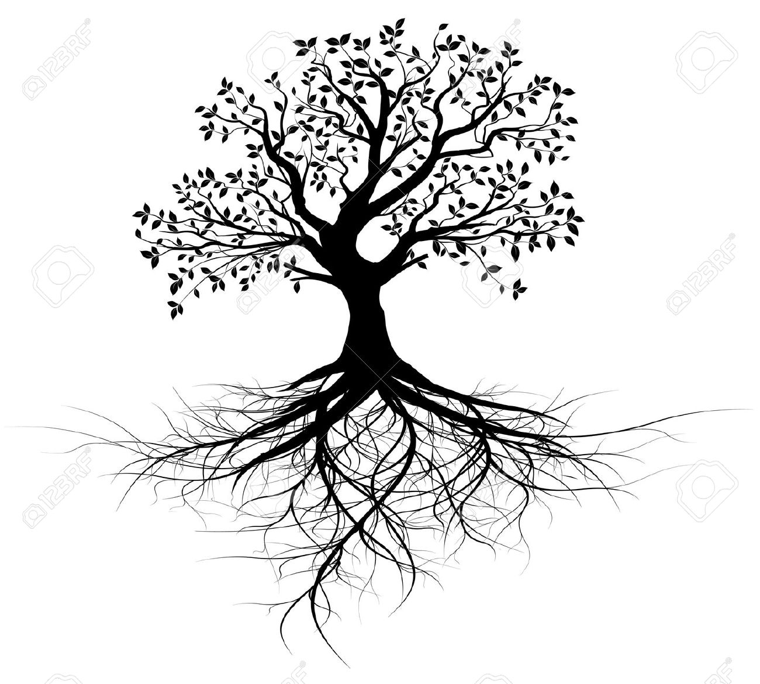

An Afternoon to Celebrate Sustainability

Saturday, January 23rd 2016

Delafield Fish Hatchery

Doors Open At 12:30PM – until 4PM

This is a FREE Event.

(Presented with A Better Delafield)

Two Floors of Activity

**First Floor:**

* Waukesha County Green Team
* Tall Pines Conservancy

Enjoy Free Popcorn,

Cider

& Music

* Wachtel Tree Service
* Clearwater Outdoor
* Wheel & Sprocket
* DNR – Urban Tree Canopy Experts
* St. John’s (Bark River Keepers)
* Wild Birds Unlimited
* WelIntel of Milwaukee
* Milwaukee Street Traders
* Kurt Kielisch – Forensic Appraiser (Trees and Their Value)
* Lapham Peak Friends
* Piala’s

**Top Floor Talks: (10 – 15 minutes each with Q & A)**

1:00 Kurt Kielisch 2:30 DNR

*Trees Add Value to your property* *Protecting/Planting Urban Trees*

1:30 Wachtel Tree Science 3:00 Waukesha County Greens

*Tree Health Assessments* *Sustainability*

2:00 Kurt Kielisch 3:30 DNR

*Trees Add Value to your property Protecting/Planting Urban Trees*

